- Show Database Command
show databases;

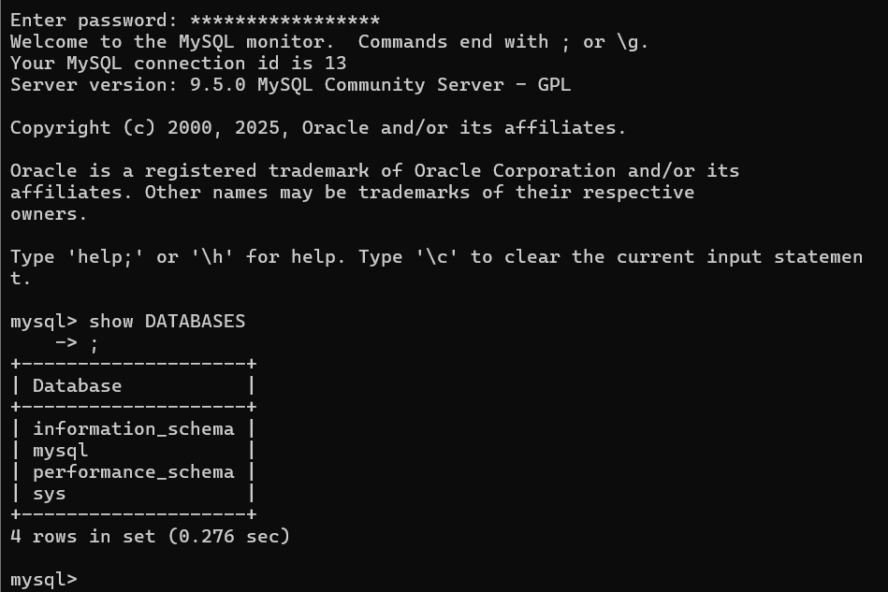

- Create Database Command

CREATE DATABASE <database_name>;
CREATE DATABASE soap_store;
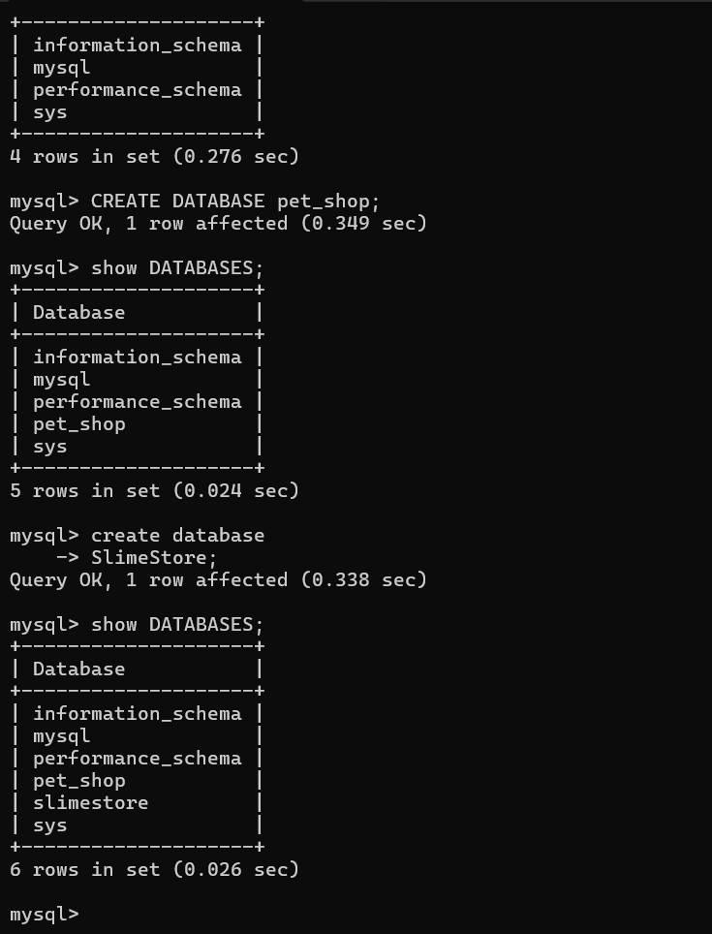
- Dropping and Using Databases
DROP DATABASE <database-name>;
USE <database-name>;

3.1 Screen Shot

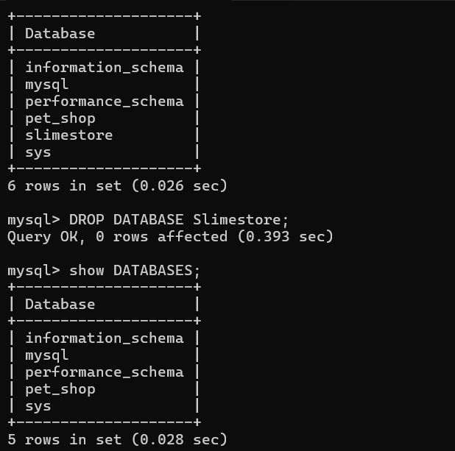

3.2 Screen Shot

Use Command
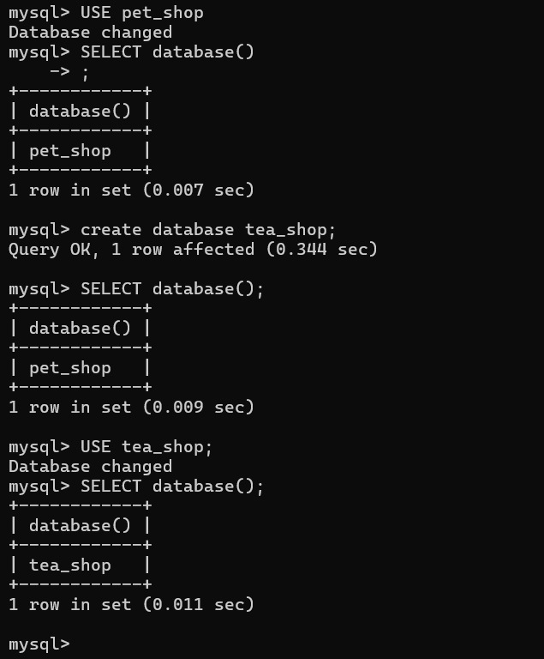
5. Data Types

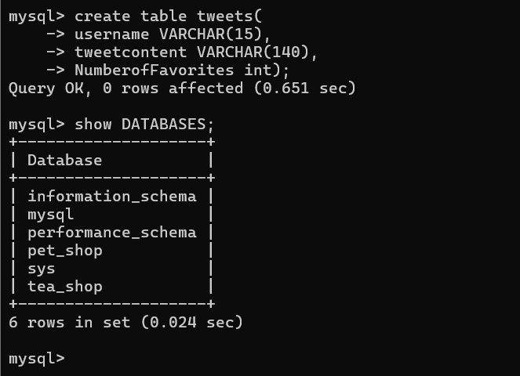

6. Creating Tables

- CREATE TABLE cats (
- name VARCHAR(50),
- age INT
- );

- CREATE TABLE dogs (
- name VARCHAR(50),
- breed VARCHAR(50),
- age INT
- );

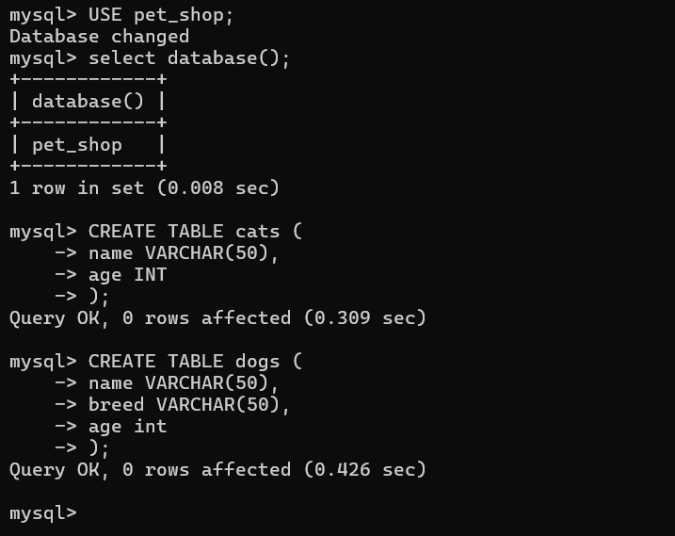

7. Show Tables

SHOW tables;
SHOW COLUMNS FROM cats;
DESC cats;

7.1 Screenshot
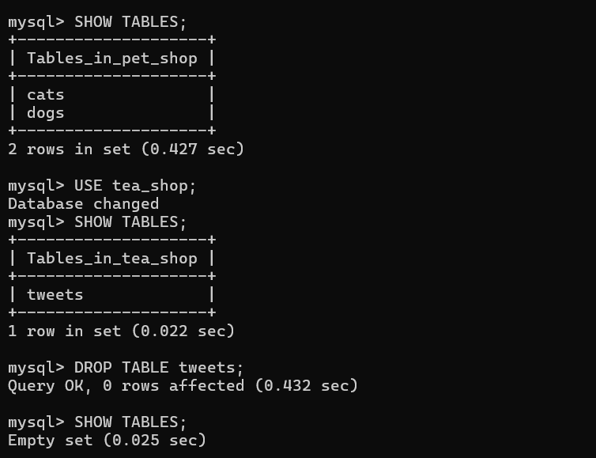

7.2 Screenshot

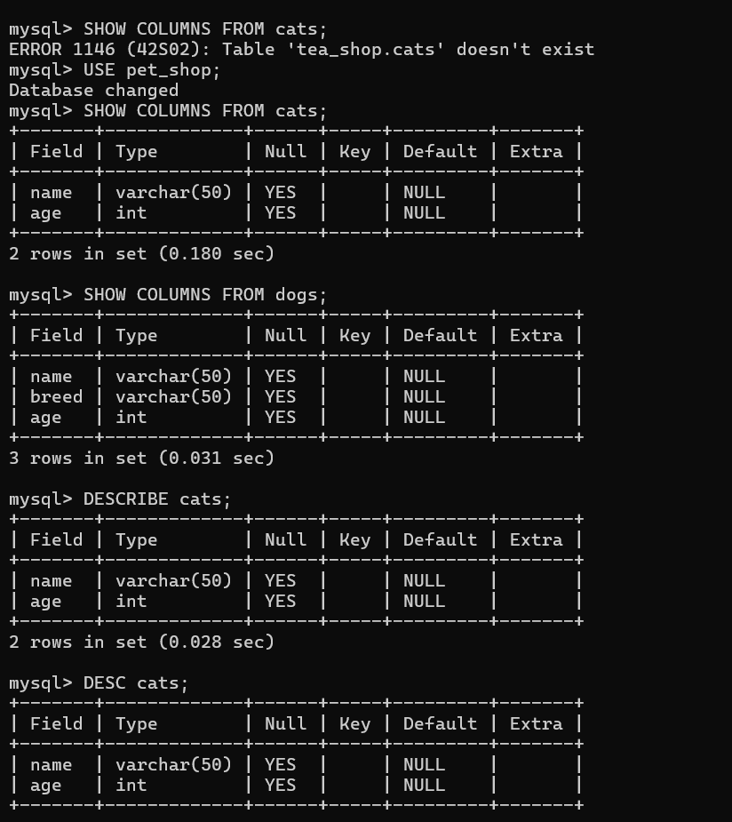

8. Drop Table

DROP TABLE <table-name>;
To specifically drop the cats table:
DROP TABLE cats;

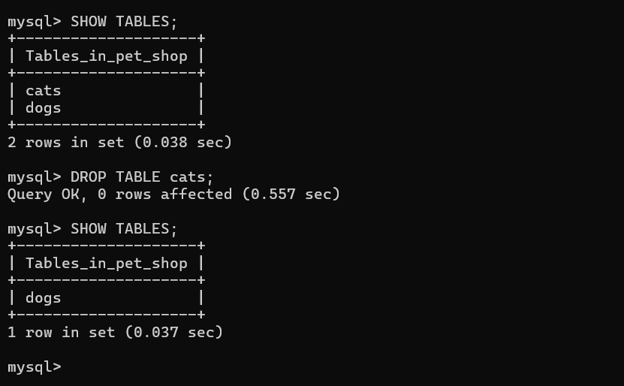

Exercise

9.1 ScreenShot

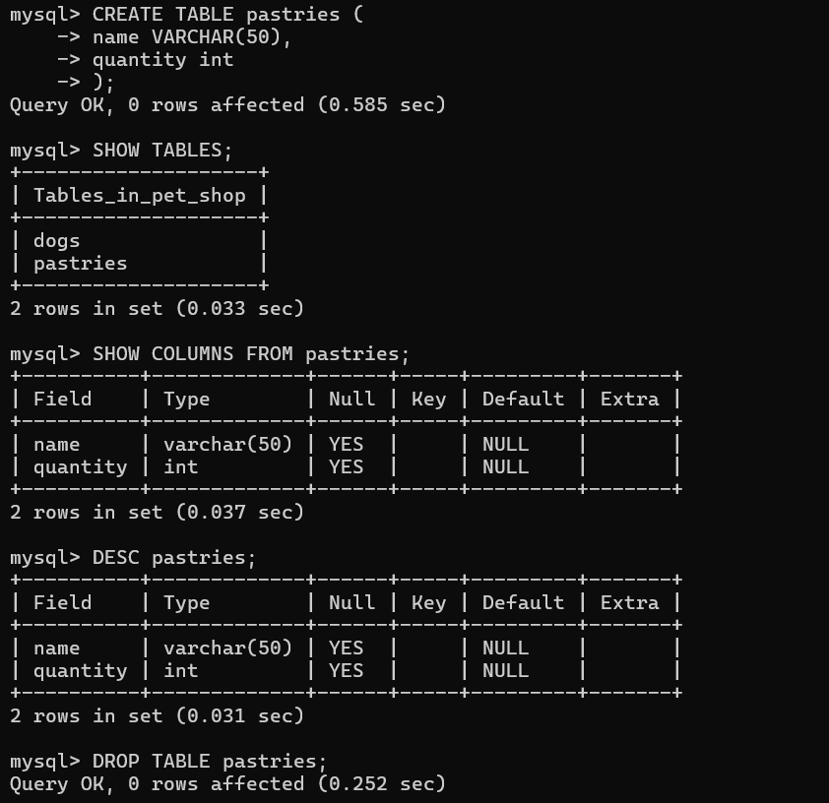

9.2 ScreenShot

